**CA-HUB KENYA PORTAL /WEB PAGE**

1. **PROPOSED MENU**

* **Home**
* Photos sliding/rolling
* Hub strategic areas
* Features stories column
* **About**
* Profile
* Membership
* Governance
* **Our Work**
* CA
* Partnership projects
* Collaborative Work
* **Resource Center**
* News and Events updates
* CA Hub Kenya Newsletter
* Success stories
* Technical Resources
* **Symposium**
* **Gallery**
* Photos
* Videos
* **Get Involved**
* Be a member
* Register your project
* Share a Blog
* Share case studies/Success stories
* Share technology photos/videos
* Donate
* **CA Hub Membership**

1. **CONTENT**

* **HOME**

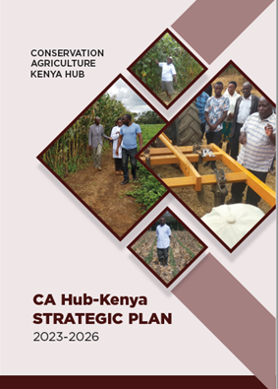

* **Photos sliding section**

Array of photos (from members activities)

* **Introductory Statement**

Kenya CA- hub is a network/platform of likeminded, multi-sectoral stakeholders engaged in advocacy and promotion of conservation agriculture and other climate smart practices through Knowledge sharing and learning (contextualized training); Research and development; and Policy advocacy for adoption and mainstreaming of Conservation Agriculture and Climate Smart Agriculture practices.

* **Hub Strategic Areas**

**Promotion + Adoption + Upscaling + Practice** of Conservation Agriculture in Kenya

* **Featured Stories**
* To Contain selected success stories or best practices
* **ABOUT**
* **CONSERVATION AGRICULTURE HUB-KENYA**

Conservation Agriculture (CA) is a crop production system that is based on three principles: minimal soil disturbance, permanent soil cover and crop rotations. Unique to CA is that it holds tremendous potential for all sizes of farms and agro-ecological systems, including those of smallholder farmers who are food insecure. Conservation Agriculture has made a significant contribution in increasing food production in areas where smallholder farmers struggle to produce food because of frequent droughts, infertile soils and labor shortages.

The CA-Kenya Hub is a network of organizations and institutions and was established in 2011. It was started by 5 (five) organizations funded by the Canadian Food Grainbank (CFGB) - MCC, CBM, World Relief Canada, World Renew, ADRA and 3 local implementing partner members: National Council of Churches of Kenya (NCCK), Utooni Development Organization (UDO), Sahelian Solutions (SASOL). Since then, CA Kenya Hub has grown to almost 20 official members and 60 participants on online platform by 2022. The CA-Kenya Hub connects organizations and builds capacity of its members to promote sustainable food security through conservation agriculture. Accomplishments of the CA-Kenya Hub include the following: trainings, linkages to conferences, exchange visits, consistent quarterly meetings as a hub, information sharing amongst members, fundraising efforts, and linking/networking with other organizations. Individually most of the members are involved in projects implemented in different counties and are aimed to promote the CA practice. They therefore bring a diversity of experience that provides a very good platform for knowledge sharing.

In light of the benefits of CA, many organizations around the world are actively working to increase their capacity to design and implement CA programs. Specific focus areas include increasing the capacity of implementing partners to train field staff on CA, scaling up the adoption of CA in communities, assuring that best practices are followed, Institutionalizing CA within the relevant organizations and policy, providing a forum to discuss challenges and learning’s and adaptations, and adding to the generalizable knowledge and learning’s of CA globally.

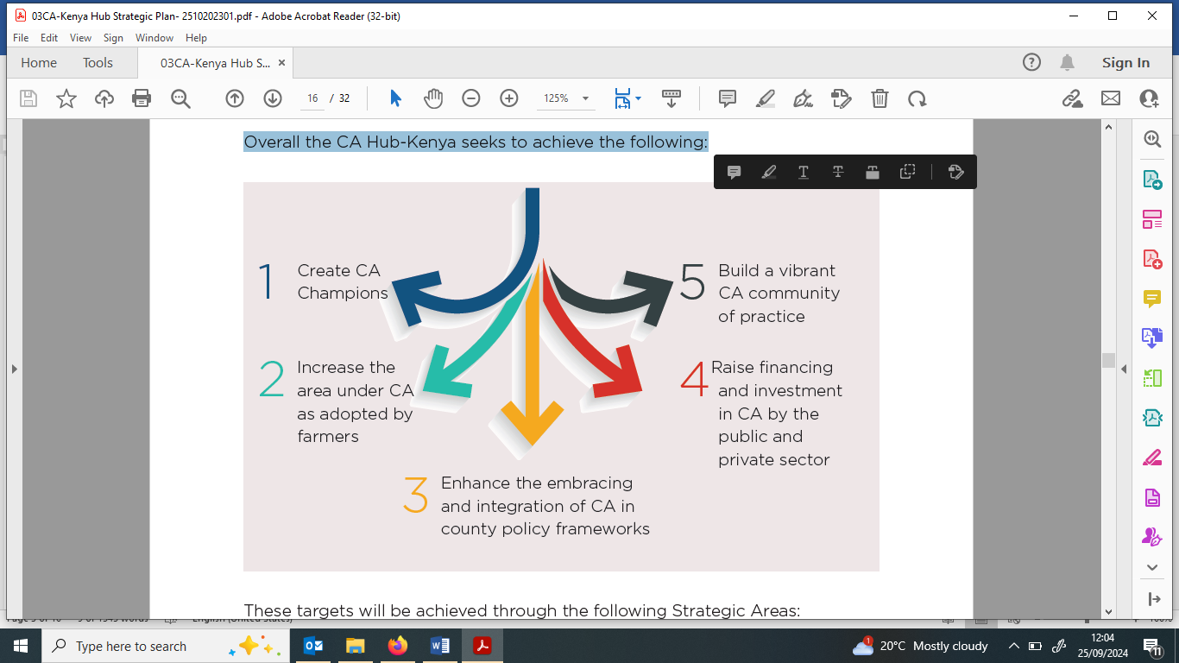Invariably , CA Hub-Kenya seeks to achieve its strategic objective through the following:

**Vision:**

A food secure Kenya and climate resilient farming systems



**Mission:**

To connect and empower its members to promote sustainable food production through conservation agriculture.



**Core Values:**

1. **Farmer and community cantered**

Producers are the core of agriculture, food and nutrition security hence are at the core of our work

1. **Partnership driven**

CA work is driven by broad partnerships of all stakeholders: government, research, academia, producer groups, private sector, civil society, development partners, philanthropists and funding partners

1. **Impact oriented**

We seek to deliver sustainable impact at scale to millions of households and actors along the CA value chain

1. **Inclusivity**

We seek to ensure equitable benefit to all actors in the CA value chain, more so to women and youth

* **Membership**

CA Hub-Kenya is a member organization currently hosted by the Africa Conservation Tillage Network (ACT), at KALRO Kabete, Nairobi. Membership to the Hub is open to organizations promoting conservation agriculture in Kenya. The organizations sign a Consortium Agreement committing to the aspirations of the CA Hub-Kenya.

**Categories of Membership**

**The potential category of members and their roles include:**

|  |  |  |
| --- | --- | --- |
| **Category** | **Potential Members** | **Roles** |
| County and National Governments | * Ministry of Agriculture, Livestock and Fisheries * Ministry of Environment & Forestry * Council of Governors (CoG) Agricultural Committee * County Line departments | * Official endorsement/ commitment * Policy Alignment to CA agenda * Building Capacity * Resource mobilization/ allocation to support CA * Coordination of CA programs and activities * Domesticating CA policy/ messages * MCA/Agric. Committee/ sensitization * Harmonizing agriculture policies/ adapting policies to Counties * Communication and information sharing |
| Research and Academia | * Research:   NARS: KALRO, KEFRI  International Research Organizations: CG Centers e.g. CIMMYT, ABC-CIAT, ILRI, ICRAF, ICRISAT, and ICIPE   * Academia:   Universities e.g. Egerton  Agricultural related Institution; ATCs, Schools: TIVETS | * Creation of knowledge/ evidence * Capacity building through training * CA Curriculum development * Package & disseminate research findings |
| Implementing Agencies (Actors) | * NGO (International & Local), CBOs, FBOs * Government extension system | * Capacity building * Service delivery * Linkages * Evidence generations * Knowledge and information sharing |
| Funders/ Donors/UN Organizations | * Bilateral and multinational e.g. EU and Others * UN organizations e.g. FAO | * Support the CA programs * Provide expertise * Linkages * Global policy support |
| Private Sector | * Inputs providers * Mechanization providers * Off takers * Service providers (financial, insurance, ICT) * Produce buyers and processors | * Develop tailored products to support CA promotion and adoption * Provide markets to farm produce * Provide inputs to farmers * Business development/Service contracting * Offers options for sustainable value chains * Provide incentives for adopting CA * Provide markets to farm produce |
| Farmer and Farmer Organizations | * Producers/growers associations * Cooperatives * Farmer groups * Individual farmer | * Farmers voice/Lobbying platform * Capacity building * Dissemination of innovations/ knowledge interface |
| Media | * Mainstream media, social media (Bloggers) | * Disseminate CA information * Lobby * Creation of awareness on CA |
| Individual (Experts/ Influential personalities) | * Professionals on CA | * Technical support * Advocacy * Business development |

* **Structure and Governance**

An elaborate structure of CA Hub- Kenya network has been established with clear roles as describe below:

1. **Secretariat:** A secretariat comprising a Program Officer, Accountant, Resource Mobilization Officer, and seconded technical experts from time to time
2. **Steering Committee (SC):** The Secretariat reports to the Steering Committee drawn from the members of the Hub. The SC will function like a Board and provide strategic leadership on the operations of the Hub.
3. **Working Groups (WG):** These are thematic teams helping deliver on the various strategic areas of the CA Hub

**CA Hub Organogram**

ACT Network

**CA Hub Kenya**

CA Hub Steering Committee

CA Hub Funding Partners

CA Hub Secretariat

Scaling CA

Research & Capacity

Partnerships, Advocacy & Policy

Communication & Knowledge management

Resource Mobilization

Working Groups

* **OUR WORK**

The CA-Hub Kenya promotes and advocate for farmers to transit to more resilient, sustainable and resource saving farming practices like conservation agriculture to build farmers resilience and enhance food security and nutrition aspects albeit climate change variabilities and impact. The Hub is intended to build synergies for wider and rapid scaling of CA through strong partnerships that ensures collective co-creation, learning and scaling of crop intensification and diversification under CA systems.

The Hub provides a platform to share experiences, raise awareness about CA, facilitate interactions among the various practitioners and contribute to enhancing the promotion and adoption of CA as a way to farm productively, improve resilience in the ecosystems, and optimize both short and long term productive-ability of the land-water systems.

**Conservation Agriculture**

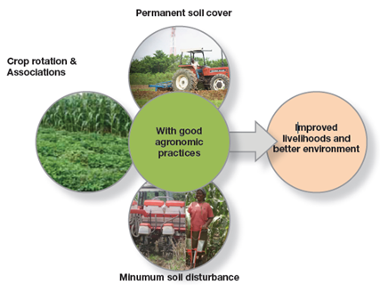Conservation Agriculture (CA) is a concept that combines profitable agricultural production with environmental concerns and sustainability. It is an approach to managing agro-ecosystems for improved and sustained productivity, increased profits and food security while preserving and enhancing the resource base and the environment. It is characterized by linked principles of continuous minimum mechanical soil disturbance, permanent organic soil cover and diversification of crop species grown in sequences or associations. These principles are universally applicable to all agricultural landscapes and land uses with locally adapted practices. CA is used in most of the world’s high-performing food production systems to strengthen soil structure and fertility, improve water retention and bring farmers savings in cost and labor for comparable yields. Unique to CA is that it holds tremendous potential for all sizes of farms and agroecological systems, including those of smallholder farmers who are food insecure. However, In Africa, conservation agriculture adoption is still facing a number of challenges, despite tremendous potentials depicted in many regions and countries that have adopted it.

Today, food systems in Kenya are under pressure from land degradation, low productivity, climate change and rapidly increasing human population. Over 46% of the land area is degraded. Land degradation and climate change mutually reinforce each other, creating serious implications for food security, biodiversity and livelihoods in Africa. Low productivity due to damaged poor soils, poor farming practices and low use of appropriate inputs, including mechanization and inadequate harnessing of digitization services are causing difficulties for rural communities to meet their food and nutrition needs as well as income. The rising human population accompanied by changing diets is increasing food demand. Food production must double by 2050 to meet the demand of the world’s growing population. This can only happen if the world adopts more productive farming practices, conserve and regenerate the limited production base and that are resilient to climate change. One such sustainable farming practice is Conservation Agriculture.

Conservation Agriculture has made a significant contribution to increasing food production in areas where smallholder farmers struggle to produce food because of frequent droughts, infertile soils and labour shortages. Ultimately CA aligns and contributes to Sustainable Development Goals: Food security, Environmental Conservation, and Biodiversity [Read more](F://ACT/ACT_KIMO/Technical/Partnership%20and%20Networking/CA-Hub%202/CA-HUb%20display/3%20principles%20of%20CA.pdf)

Strategically, CA Hub-Kenya network aims to create CA Champions, increase the area under CA as adopted by farmers, enhance the embracing and integration of CA in county policy frameworks, raise finances and investment in CA by the public and private sector and build a vibrant CA community of practice. To achieve these targets, the Hub is focused on the following **strategic Areas:**

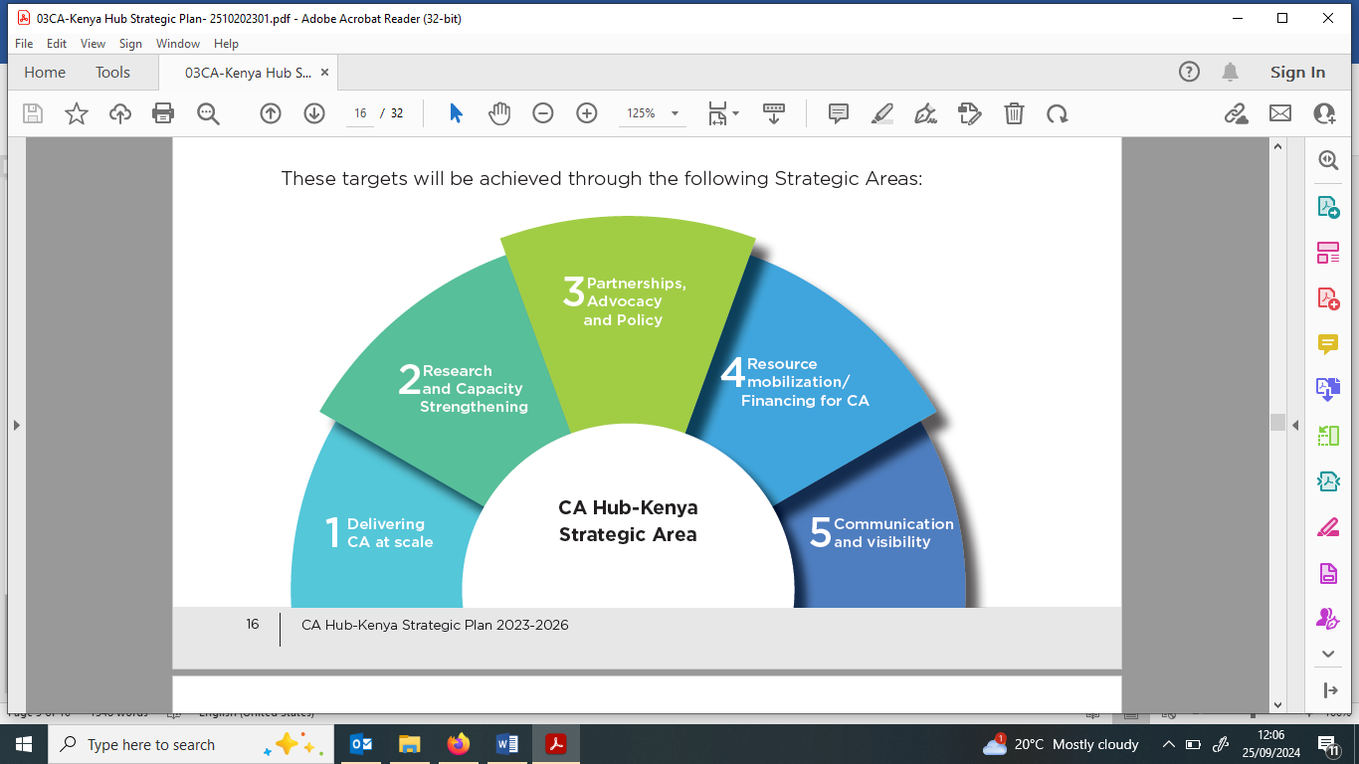

**A. Delivering CA at Scale**

The impact of CA can empirically be measured by the extent of adoption, acreage covered and livelihoods transformed. Thus, delivering CA at scale forms the basis for advocacy hence a critical component of the Hub. CA as a Community-based adaptation to climate change means community-led CA processes based on communities’ priorities, needs, knowledge, and capacities, which should empower people to plan for and cope with the impacts of climate change.

**B. Research and Capacity Strengthening**

Africa’s agriculture is in great need of reform to minimize and eventually eliminate land degradation, improve yields per unit area, reduce the drudgery especially for smallholder farmers, sustain productivity and profitability and enhance environmental conservation. This strategic area aims at developing the capacity for innovations of the millions of smallholder farmers whose traditional practices (even where effective) are largely ignored or underrepresented. Research and capacity strengthening will be accomplished through awareness creation, advocacy, participation in CA related conferences and meetings, setting up demonstration/ institution sites in institutions that offer short CA training courses, establishment of the CA Centre of Excellence (CoE) at KALRO Njoro.

**C. Partnerships, Advocacy and Policy**

The mainstreaming and scaling of CA to national policies, frameworks and programmes requires the scientific evidence to convince the buy-in of policy makes and investors. Collective and concerted efforts are needed give voice to individuals and groups whose concerns and interests are not being heard in the advocacy for policy change to mainstream CA. This strategic area will be delivered by undertaking the following activities: mapping and linking different stakeholders, development of CA courses for various training institutions and agents, collectively advocate for CA mainstreaming in training institutions and extension systems.

**D. Communication and Visibility**

The communication and visibility strategic area aims at promoting and communicating the efforts and results of the CA-Kenya Hub. The Strategic Area will focus on: Development of the CA-Hub Kenya portal; Systematic creation, acquisition and documentation of CA Technologies, Inputs, Practices and Services (TIPS) relevant to opportunities and constraints; Development of CA knowledge & information (K&I) sharing products; Enhanced digital communication channels with targeted influencers; Media relations (forums, press briefings, events], and communication Toolkit (A to Z of CA).

**E. Resource Mobilization/Financing for CA**

The goal of this Strategic Area is to raise resources for the CA hub in its entirety. The resources are to support the CA Hub Secretariat- as convener and the partners’ initiatives through joint CA projects and activities.

* **Partnership projects**

|  |  |  |
| --- | --- | --- |
| Project and Location | Partners Involved | Description of project, Main activities and Achievements |
| ACT – AICCRA Project.  Location: *Muranga, Tharaka Nithi and Makueni* | CIAT and County Governments |  |
|  |  |  |
|  |  |  |

* **Collaborative Work**

|  |  |  |
| --- | --- | --- |
| Project /Work and Location | Hub Members involved | Main activities and Achievements |
| Kenya National Conservation Agriculture Conference,  at Safari Park Hotel, Nairobi on 17-19 April 2018 |  | Successfully organized in partnership with FAO, the Kenya Conservation Agriculture Conference, at Safari Park Hotel, Nairobi on **17-19 April 2018** brought together key partners among them the European Union (EU) and the Council of Governors (CoG). It was after this conference that the Hub gained impetus and started developing the necessary structures to steer the CA agenda in Kenya. |
|  |  |  |
|  |  |  |

* **RESOURCE CENTER**
* **News and Events updates**
* News
* Events
* CA Hub -Kenya Newsletter
* **Success stories**
* **Technical Resources**
* Building networks and partnerships for effective knowledge sharing and promotion of Conservation Agriculture – The case of CA Hub-Kenya. Paper presented at 3ACCA in Rabat Morocco on 5-8 June, 2023
* Adoption and Practice of Conservation Agriculture (CA) and CA-Based Mechanization in Selected Counties in Kenya. Paper presented at 3ACCA in Rabat Morocco on 5-8 June, 2023
* CA Hub-Kenya Strategic Plan 2023-2026
* [Conservation Agriculture: A Manual for Farmers and Extension Workers in Africa](https://act-africa.org/176/conservation-agriculture-manual/)
* CA Hub- Kenya Consortium Agreement
* **GALLERY**
* **Photos**

(Well caption photos from Members uploaded)

* **Videos**

(Well caption videos and video links from Members uploaded)

* **GET INVOLVED**
* **Be a member**

As an organization / institution promoting CA in Kenya, you can become a member of the Hub by expressing your interest for consideration by the Steering committee by providing organizations details indicated in the form. The Steering committee once satisfied with your intention will share with you the ‘Consortium Agreement’ for your organization to commit to operation of the CA Hub.

For any inquiries contact the CA Hub Kenya Secretariat: Peter Kuria | M: 0722451704 | E: [peter.kuria@act-africa.org](mailto:peter.kuria@act-africa.org).

If interested to be CA Hub-Kenya Member, kindly **Register Here**

**Registration Form**

1. Indicate the name of your Organization / institution

Acronym of your Organization Name

1. Share the name of organization’s contact person & designation

1. Provide the address of your organization

1. Please indicate the category of your organization

National Government Department/ Parastatal

County Government

National Research organization

International Research organizations

Academia e.g. Universities, TVETs, NGO/Development Partners,

Funders/ Donors / UN Organizations

Agricultural machinery dealer and Mechanization Service provider company

Finance and Credit institution

Agro-input Dealers,

Off takers / Produce buyers companies / Aggregators

Farmer and Farmer Organizations,

Media

1. Provide the link to your Website

1. Indicate the Counties and Wards your organization operate in.

1. Please provide details of your active CA Projects/Programs/Initiatives your organization is currently engaged in

1. Please list down some of the Conservation Agriculture Technologies /practices your organization is promoting.

1. Who are your collaborating / Scaling Partners?

1. Who is your Donors/Funding Partners (*Provide if allowed*)?

* **Register your project**

If you a member of this network and you have an active project, kindly register with us by providing a summary of your project in the form provided below:

|  |  |
| --- | --- |
| Project Registration | |
|  |  |
| Project Name/Title |  |
| Project locality |  |
| Partners Involved |  |
| Description of project (Main activities) |  |
| Achievements / Milestones |  |
| Source of project funds |  |
|  |  |

* **Share a Blog**

If you a member of this network and you have a CA based interesting innovations and achievement, kindly share with us its summary as an article in the form provided below (*these blogs will be periodically compiled into CA Hub Kenya Newsletter*):

|  |  |
| --- | --- |
| Blog | |
|  |  |
| Title |  |
| Locality |  |
| Summary / Description |  |
| Key issues |  |
| Refences /additional information |  |
|  |  |

* **Share case studies/Success stories**

If you a member of this network and you have a CA based success stories or best practices, kindly share with us a summarize profile of it as an article or video(with links) in the form provided below (*The success stories/best practices will be periodically compiled and included in CA Hub Kenya Newsletter*):

|  |  |
| --- | --- |
| Success story / Best practices | |
|  |  |
| Title |  |
| Locality |  |
| Summary / Description of the story/ case study |  |
| Notable Key issues |  |
| Refences /additional information |  |

* **Share technology photos/videos**

If you a member of this network and you have a CA based pictorials /photos and videos/podcast on the various CA technologies, kindly share with us.

(They should be well captioned to include the locality and the date*. These will be used to update the gallery section*):

|  |  |
| --- | --- |
| Photos and Videos | |
|  |  |
| Photo caption / Video title |  |
| Locality |  |
| Description of the photo / Video |  |
| Links |  |

* **Donate**
* 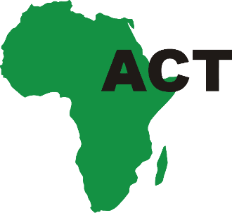**CA-HUB KENYA MEMBERSHIP**

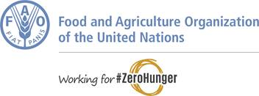



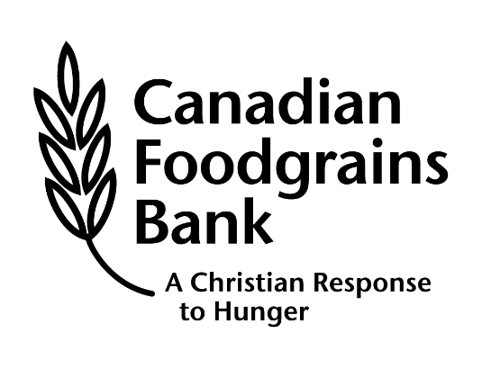



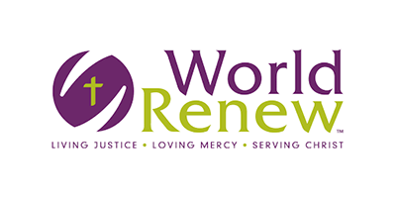

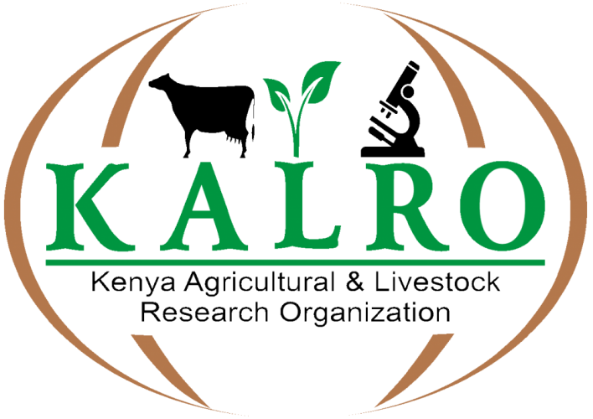





* **KENYA CA- HUB SYMPOSIUM**

**Conservation Agriculture: Profitable, Sustainable and Resilient Farming with Conservation Agriculture in Kenya**

**8 AM - 5 PM EAT | 12 March 2025 | Pride Inn Azure, Nairobi, Kenya**

**Organizers: Africa Conservation Tillage Network (ACTN) and the Conservation Agriculture Hub Kenya**

**Introduction**

Although Conservation Agriculture (CA) uptake levels are still relatively low in Kenya (Mkomwa et al., 2017), the use of CA is more prevalent in commercial than small scale agriculture, whereby around 10 large scale commercial farmers manage 72% of the close to 30,000 ha under CA in the country. This can perhaps primarily be attributed to the very complex smallholder farming system and the factors influencing it, such as land tenure, lack of resources and infrastructure among others, demanding a special approach and skills to empower and adapt these farmers and their systems to CA.

The introduction and promotion of CA in Kenya have been supported by development partners, not-for-profit organizations coordinated under the CA Hub Kenya, and the government. The CA Hub Kenya is a consortium of nearly thirty (30) organizations, doing work around sustainable farming and building partnerships for effective delivery and synergies. Increasing interest and support to CA by the Kenyan government was expressed through a declaration made in April 2018 during the first CA Kenya Symposium to scale Conservation Agriculture adoption by over 10% of the farming population in Kenya.

While the CA concept has been generally endorsed and accepted by different practitioners including those from research, extension, and learning institutions, there remains significant challenges to the integration of CA concepts and practices in their developmental programs within the existing agricultural extension, education, research, and farming community systems. The scaling of CA is lower than the potential commercial, environmental, and social benefits it is poised to deliver, and the gap needs to be demystified and addressed.

**About the Symposium**

The Conservation Agriculture Conference 2025, organized by the by the CA Hub Kenya hosted by the African Conservation Tillage Network, brings together key CA stakeholders to interact, synthesize, and share CA best practices and provoke strategic thinking on how to collaboratively promote and scale the adoption of the CA technologies, inputs, practices and services.

The symposium aims to spur conversations on Conservation agriculture, deepen the progresses already made by different actors in addition to addressing the challenges that may still exist and taking BOLD STEPS that will enable farmers take up the CA practises and help build sustainable food systems in Kenya.

**Symposium Objectives**

The overall objective of the symposium is to bring together CA stakeholders (farmers, advisory/extension staff, researchers, academia, policymakers, inputs/machinery manufacturers, and suppliers), to interact, synthesize, and share CA best practices and provoke strategic thinking on how to collaboratively catalyse the scaling up and reaping the benefits from the adoption of the CA technologies, inputs, practices and services.

***Specific Objectives***

1. To share evidence of best practices from small, medium, and large–scale farmers to exemplify the relevance and urgency of CA now.
2. To demystify and challenge the CA adoption data for Kenya, ascertain the root causes, and support formulation of corrective interventions.
3. To probe key interventions, including – extension and capacity building, mechanization services and digitalization, policy support, research for development, financing/credit, and markets - to catalyse the scaling and mainstreaming of CA into Kenya’s Government and County programs and strategies.

**Expected Symposium Outcomes**

1. Enhanced understanding of the Conservation Agriculture root causes and opportunities
2. Strategic recommendations to address barriers to wide-scale adoption of CA in Kenya
3. New and strengthened partnerships for ushering CA adoption
4. Summarised outcomes to guide action and advocacy for CA

**Symposium Approach**

The symposium is designed to walk the participants, step-by-step, through the process of experience sharing, exchanges, and building consensus on innovative aspects that will enhance adaptation, adoption, and scaling up of smallholder CA for improved agricultural productivity, sustainable land management, and environmental conservation. The one-day event is designed as a hands-on activity with a logical combination of plenary presentation and discussion sessions, group discussions, and feedback sessions of best CA practices. Each discussion group session shall have clear terms of reference. The feedback sessions shall be used to present each group’s report and shall be done in a plenary set-up. This participatory process is expected to facilitate consensus building and agreement on the issues under discussion by all the participants and come out with proposed practical interventions.

**CA Success Stories**

Organizations and individuals are encouraged to submit CA success stories that will be evaluated and the best awarded. Refer to the criteria of stories and submit your story using the link below.

All stories will be published and featured on the CA Hub page hosted on the ACTN website.

**Participants**

The symposium will analyse the constraints to and benefits of adoption of CA in dedicated value chains for small, medium, and large-scale farmers, and challenge the advisory, research, academia, and industry service providers to deliver solutions and or propose scaling pathways. Participants will therefore be drawn from all agricultural sectors including the Ministry of Agriculture and Livestock, County governments, agricultural research, government institutions, higher learning institutions, non-governmental organizations, farmer organizations, the private sector, and related development partners in Kenya. We anticipate to bring together 80 participants to this symposium.

**Symposium programme**

This program contains an overview of the activities that are required to deliver the expected symposium outputs and hence the symposium's purpose. The program shall be flexible without losing focus and shall be adjusted on a session-by-session basis in a rolling program approach to accommodate emerging issues as the symposium progresses.

**SYMPOSIUM PROGRAMME**

**Conservation Agriculture: Profitable, Sustainable and Resilient Farming with Conservation Agriculture in Kenya**

**| 9 AM - 5 PM EAT | 12 March 2025 | Pride Inn Azure, Nairobi Kenya |**

|  |  |  |
| --- | --- | --- |
| **TIME** | **ACTIVITY** | **RESPONSIBILITY** |
| **SESSION I** | **OPENING SESSION**  **Chair:** Agricultural Committee, Council of Governors, Kenya |  |
| 08:00 – 08:30 | Arrival and registration | Secretariat |
| 08:30 – 08:45 | Welcome statement, Overview of ACT network and CA, Symposium background and objectives | Saidi Mkomwa, CEO ACTN |
| 08:45 – 09:00 | Participants’ introduction and expectations: Interactive exercise | Stephan Lutz *World Renew* |
| 09:00 – 09:10 | Opening remarks by 2-3 invited guests | Guest speakers |
| 09:10 – 09:25 | Keynote address – *Why Conservation Agriculture is more relevant and urgent in Kenya now more than ever*. | Boaz Waswa, *CA Hub Chair* |
| 09:25 – 09:45 | Official Opening Remarks – Principal Secretary for the State Department for Agriculture in Kenya | PS MoAL [tbc] |
| **09:45 - 10:30** | **Group Photo/ Coffee/Tea Break** |  |
| **SESSION II** | **FOCUSING ON BEST CA PRACTICES AND DEEP DIVING TO SCALE THE LESSONS LEARNED**  **Chair:** Mechanization Service Provider, Prof Paul Karuri |  |
| 10:30 – 11:00 | Presentation of Best CA Practices, seven (7) minutes each, by: |  |
| * A smallholder farmer | Farmer xx1 |
| * A medium-scale farmer | Farmer xx2 |
| * Large-scale commercial farmer, AgVenture | Farmer xx3 |
| * Development partner experience, World Renew | World Renew |
| 11:00 – 11:10 | Plenary discussion: Q&A; key lessons learned from the case studies |  |
| 11:10 – 11:20 | Clarification of thematic group Terms of Reference, grouping of participants, Chairs and Rapporteurs | Facilitator |
| 11:20 – 12:00 | Thematic group discussions [1. Mechanization and digitalization; 2. Financing and credit; 3. Extension and capacity building; 4. Research for development; 5. Produce market pull/linkages] on key lessons learnt, opportunities and enablers to CA scaling, root-causes to scaling of CA, the necessary remedial interventions, and by who? | Thematic Group Chairpersons |
| 12:00 – 13:00 | Group presentations and plenary discussions on Best CA success stories, Enablers, Opportunities to scaling, & Needed interventions | Group Rapporteurs |
| **13:00 - 14:00** | **Lunch Break** |  |
| **SESSION III** | **STREAMLINING CA INTO PUBLIC AND PRIVATE SECTOR PROGRAMS & STRATEGIES**  **Chair:** CA Hub Kenya Chairperson, Boaz Waswa |  |
| 14:00 – 14:10 | Mainstreaming CA in Kenya. What are the implications of having 10% of the farmed area in Kenya being under CA? Where is the holdup and how to unlock it? | David Njogu *(MOAL)* |
| 14:10 – 14:20 | Clarification of thematic groups [1. Creation of the enabling environment (policy support); 2. Programmatic financing and investments; 3. Extension, advocacy and capacity building; 4. Research for development; 5. Partnerships and coordination]. Terms of Reference, Grouping of participants, Chairs/Rapporteurs | Facilitator |
| 14:20 – 15:00 | Thematic group discussions on challenges and proposed interventions to streamlining CA into public and private sector programs and strategies | Group Chairs |
| 15:00 – 15:30 | **Group Presentation & Plenary discussion** | Rapporteurs |
| 15:30 – 16:00 | Symposium conclusions and discussion |  |
| 15:55 – 16:00 | Vote of thanks and closing |  |
| **16:00 – 16:30** | **Coffee/Tea and Networking** |  |
| 16:30 | Departure |  |

**Participation Fee**

This is a self-sponsored symposium. The registration fee for the symposium, covering and limited to venue and meals, is KES. 5,000 per person. The symposium core budget will be met principally by the CA Hub Member organizations. It will be complimented by development partners, and private sector stakeholders with interest in scaling CA. Each CA Hub Member is encouraged and expected to sponsor a minimum of four participants with travel and accommodation for the one-day meeting as well as the registration fee of KES 20,000 for the four sponsored participants. It is expected that one of the sponsored participants is a farmer.

Corporate sponsorship of the symposium is welcome. A sponsoring organisation will be acknowledged on all the symposium publicity materials and media outreach related to the symposium. Corporate sponsorship will be in the following categories:

| Gold: KES 250,000 | Silver: KES 125,000 | Bronze: KES 50,000

Payments should be made to the CA Hub Kenya Secretariat using the following bank account, with payment confirmation slips being forwarded to [accounts@act-africa.org](mailto:accounts@act-africa.org):

Account Name: "AFRICAN CONSERVATION TILLAGE NETWORK"

Bank Name: NCBA Bank

Branch: Westlands Branch, Nairobi

Country: Kenya

Account No: 6590190018

Swift Code: CBAFKENX

**Registration**

The CA Hub Kenya Secretariat expects to receive Expressions of Interest to participate by 30th January 2025. Sponsorship should be made by 30th January 2025.

Participants are welcome to register for the symposium, by filing in the form, click [THIS LINK](https://docs.google.com/forms/d/e/1FAIpQLSfUZVqmcj4qZIl0tcJAL4ziTAfb01JssZaqO1Cr5kRYP71YOA/viewform).

**For enquiries**, contact the CA Hub Secretariat at: Email: [info@act-africa.org](mailto:info@act-africa.org); WhatsApp: +254 774895077

**Background**

Agriculture is an essential component of Kenya’s economy. In recent years, agriculture in the country has experienced profound and rapid changes due to unprecedented population growth and subsequent increase in the demand for agricultural products. Therefore, agricultural production must be subsequently transformed to meet the ever-growing demand in the country. However, traditional agricultural practices have consistently contributed to soil health degradation and erosion, thus significantly reducing their fertility and consequently hampering food production and economic security.

In the country for instance, the yield of maize crop, which is synonymous with food and nutrition security, has declined over the years, from 42 million bags in 2020 to 36.7 million bags in 2021 and to 34.3 million bags in 2022 owing to many factors. In fact, over the longer term, maize yields have declined by over 200%, dropping from 40 – 50 bags per acre (9 - 11 tons/ha) in the early seventies to 13 – 20 bags per acre (3 - 4.5 tons/ha) currently being realized. Research and extension efforts over the same period concentrated on six factors, namely: improved seed varieties, adequate fertilizer application, crop protection, optimum plant population, timely planting, and weed control. Although adoption of these prevailing recommendations has been reasonably good, the impact on the average maize yields has been insignificant. This has demonstrated that the problem is beyond these research-refined recommendations. Soil health has been the missing piece to the deteriorating maize yield puzzle. The yield decline has been majorly attributed to continuous soil disturbance by disc ploughing, disc harrowing, and in some cases burning of crop residues.

Soil health deterioration in soil erosion, plough pan formation, low organic matter content, and poor microbial activities has been evident, especially among medium and small-scale farmers in Kenya. Adopting sustainable farming practices such as Conservation Agriculture (CA) presents promising options for conserving and regenerating the production base and resiliency to climate change.

Conservation Agriculture (CA) is a crop production system that is based on three principles: minimal soil disturbance, permanent soil cover, and crop rotations. Farmers now apply CA on over 205 million hectares (15% of the world’s annual cropland area) in over 100 countries across a diverse range of agro-ecological zones and farm sizes, in all continents. There are over 3.2 million hectares of annual cropland in Africa under CA and an estimated 30,000 hectares in Kenya. CA is the largest existing model of climate-smart agriculture (CSA) worldwide in terms of surface area. Conservation Agriculture requires low investment, minimizes labour, and is a relevant innovation close to traditional and current practices of the millions of smallholder farmers. It has enhanced farm production and reduced costs while conserving and enhancing the natural resources of land, water, biodiversity, and climate.